IFG Explore
3rd Year
Term Four – Weeks four to seven Giving a Performance Spiritual

Note: Final fling/Awardz night is included in this subject.

The Gift of the baby Jesus
Aims:
To produce a performance telling the story of the birth of Jesus Christ and share it with families and friends.

To use skills to make Christmas crafts for gifts

Objectives:
- To teach girls skills in acting to give a performance
- To teach the girls simple crafts to give away

Equipment Needed:
- Materials to make props
- Glue, scissors and felt pens
- Other materials as necessary for Chosen crafts

Preparation:
Collect equipment and materials needed

Pre Setup:
Place all the craft equipment and materials out on a table so the girls can easily access them.

Set Up:
Commence the formal part of the evening with roll call etc.

Devotions:
As the play is based on the story of the birth of Jesus – maybe this could be the basis for short devotions and prayer time for the three weeks.

Activity Session:
Play games from Games book.

Teaching/Activity Session -
The Play and Song -:
Song - The Twelve Days of Christmas
The History:
The Twelve Days of Christmas was written during the 16th century religious wars of England. It was used as a tool to secretly teach children the basic doctrines of the Christian faith. The 'true love' represents God, the 'me represents the believer in Jesus Christ, and the 'partridge represents Jesus Christ. The song presents Christ as a mother partridge covering her chicks, recalling the expression of Christ's sadness over the fate of Jerusalem: "Jerusalem! Jerusalem! How often would I have sheltered you under my wings, as a hen does her chicks, but you would not have it so ...." (Luke 13:34)
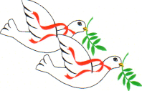
The Song:
On the first day of Christmas my true love gave to me = My true love is symbolic of God the Father.
A partridge in a pear tree = Jesus Christ (The pear tree is symbolic of the cross).
Two turtle doves = The Old and New Testaments.
Three French hens = Faith, hope and love
(1 Corinthians 13:13)
Four calling birds = The Gospels Matthew, Mark, Luke and John.
Five golden rings = The first five books of the Bible (Gen, Ex, Lev, Num, Deut)
Six geese a laying =The days of creation (Genesis 1:1-31)
Seven swans a swimming = The gifts of the Holy Spirit. (Romans 12:6-7, 1 Corinthians 12:7-11)
Eight maids a milking = The Beatitudes (Matthew 5:1-12)
Nine ladies dancing =The Fruits of the Holy Spirit (Galations 5:22-23)
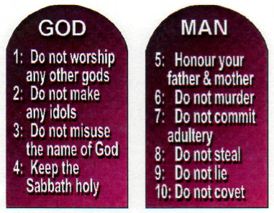
Ten lords a leaping = The Ten Commandments (Exodus 20:1-17)
Eleven pipers piping = The eleven faithful disciples.(Matthew 6 : 14-16) not including Judas, the betrayer.
Twelve Drummers drumming = The beliefs listed in the Apostles Creed.

Christmas Play - And the Animals Talked

Animals in a Bethlehem manger get a major surprise when two humans are arrive in their barn.
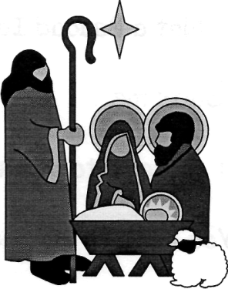
Characters
Narrator
Donkey – Brutus
Cow – Gertie
Sheep - Beatrice
Goat – Antonie
Doves – Harry & Jerry

Script
Narrator: We have read about the animals in the stable the night Jesus was born. There's even a hymn, but what did the animals really say??? Let's take a look at the night through the eyes of the animals...
Donkey: When is the innkeeper going to feed us? I'm starving.
Cow: Pipe down over there. All I need is him trying to milk me after he's tossed back a few glasses of his watered down wine. You'd think he was climbing a rope.
Donkey: Ain't life rough. At least you get some attention.. All I get is hitched to a wagon and whipped.. Thank goodness for tough hide.
Sheep: Will both of you quit the moanin! At least he doesn't look at you like tomorrow's Blue Plate Special...
Goat: (Monotone) Who really cares what you guys think. Life is good. Eat and Sleep. What a life.
Doves: Hey guys, we've got company!!!
Cow: Whooooo is it???
Doves: It's a man and woman on a donkey.
Donkey: Alright. The night is looking mighty fine.
Cow: Can the chatter!!! What can you see??
Doves: They went to the door of the inn and were turned away.. Wait, the
innkeeper is leading them this way..
Cow: RED ALERT!! Let's keep the talking to a minimum...
Sheep: Not a Baaaad Idea.
Goat: Suits me...
Donkey: I need to get my mane in order.
Cow: You need to get more than that in order. Look out, here they come.
Sheep: My goodness. That girl is HUGE!!!
Goat: Last time I saw something that big, the innkeeper was having a guest over. Something about the fatted calf.
Donkey: I wonder what her problem is???
Cow: Keep quiet and we'll find out!!! (Long Pause) Well, I'll be!!
Doves: What??
Sheep: Yeah, Gertie. What??
Cow: She's going to have a baby.
Goat: Can't have a baby here. Wouldn't be right.
Donkey: I can't believe it! Are you sure???
Cow: Just as sure as I am that it's a male donkey she was riding.
Donkey: (Dejected) Terrific-Sheep: What else are they saying?
Cow: They have come a long way. Something about a census. Oh, my.
Donkey: What?!?!? What?!?!?
Doves: What!?!?!
Cow: You heard me. She's having the baby. Alright team. Let's pitch in. Brutus. Let's sacrifice some straw.
Donkey: OK, but I don't have much.
Cow: It will be enough. Beatrice, why don't you move close to the mother and let her rest on you.
Sheep: You bet Gertie.
Cow: Antoine.
Goat: Yeah.
Cow: Don't chew on anything.
Goat: Ok.
Cow: Harry and Jerry, you keep watch.
Doves: We'll do.
Cow: My word... What's going on!?!?!?!
Donkey: I don't know, but I think something BIG is happening!
Doves: I'd say you're right. There's a huge star in the sky and the light leads down to here.
Sheep: Oh my. He's Beautiful-
Goat: Thank goodness. Hate for him to be ugly.
Cow: Oh my word. I think we've just witnessed something...
Donkey: Something is right...
Sheep: I can't believe my eyes.
Doves: We're going to tell all the other animals about this.
Goat: WOW...
Cow: Who knows? They may write a song about this.
Donkey: We could be immortalized
Sheep: We could become the things legends are made of.
Goat: We could become Supper.
Everyone: ANTOINE!!!
Goat: Sorry. Just my sense of humour.
Cow: Tonight has been a special night. One I know people will be hearing about for generations.
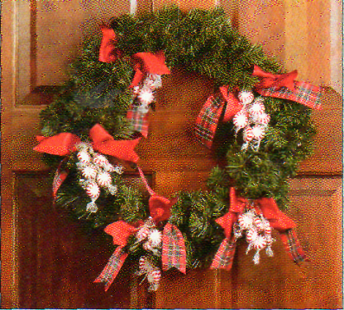
-------------
Crafts for Christmas
Minties adorn this Christmas wreath
Clusters of mints decorate this Christmas wreath. Start with an artificial evergreen wreath. Tie one wrapped mintie to the end of each 12cm piece of gold metallic string. Cluster three sweet strings, then tie to wreath with bows. Use 5cm-wide red satin and 5cm-wide red plaid ribbon for bows. Thread bunches of sweets through the middle of the bows. Attach bows to wreath with red or green pipe cleaners, allowing sweets to dangle from bows.

Hanging Advent Calendar
Materials
red or green crepe paper ruler, scissors
wire coat hanger cellotape, glue
25 small gifts or sweets wrapping paper
cord or fine string white paper
black felt pen Christmas decoration
Method:
1 Cut a 2.5cm strip off one end of the crepe paper.
2 Carefully wind the crepe paper around the coat hanger and secure the ends with cellotape.
3 Wrap each gift, or two-three sweets, in wrapping paper, leaving one end open.
4 Cut cord or string into 25 pieces, making sure each piece is long enough to hang freely from the coat hanger. Tie each piece to the end of each gift.
5 On the white paper, cut out 25 circles and write on each one a number from 1 to 25. Glue one number on each gift.
6 Tie each gift to the coat hanger, making sure that they are all hanging at different levels.
7 Glue the Christmas decoration to the top of the coat hanger.

Handprint Christmas tree craft
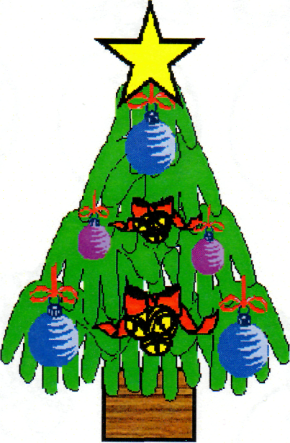
This Christmas tree is made entirely of handprints. Use a heavy paper, craft foam or poster board for a longer lasting version.
The craft is made with paper, some crayons, scissors, string and glue.
Method:
Trace the child's hands many times (at least 10) on green paper/craft foam. Alternatively you could make green paint handprints on paper.
Cut out the handprints and glue them together with fingertips facing down to form a tree shape (see picture).
Glue a brown rectangle trunk.
Decorate with stickers or the ornaments as attached. The ornaments look nice when highlighted/coloured in with sparkle glue. You can also add the child's name and the year. Add a string if you wish to hang on the tree.
You can use LOTS of handprints to make a tree big enough to hang on the door.
You could glue a picture of the child in the centre of the tree for a keepsake.

Notices and Home Time:
Notice to family and friends about award night and the Performance of the Play. Invite Church congregations.
An idea may be for everyone attending to bring a gift for those in need ie food bank recipients, or children of prisoners etc
End evenings with a prayer

Final Night:
Preparation:
Have a decorated Christmas tree in corner of hall.
If not already planned for the Play, decorate an area to look like a stable.
On the Night:
As everyone arrives invite them to place their gifts under the Christmas tree.
Present the play to family and friends. Award badges followed by supper.

